CONTROL SYSTEMS
QUESTION BANK

UNIT-I SYSTEMS COMPONENTS AND THEIR REPRESENTATION
PART-A

What is control system?
In a system, when output quantity is controlled by varying the input quantity, then it is called as control system.

What are the advantages of closed loop control system? (AUC, May-June 2012, Nov-Dec 2012)
  - The closed loop system are accurate
  - The closed system are accurate even in the presence of nonlinearities
  - The closed loop systems are less affected by the noise.

What are the types of control system and explain it? Open loop system:
Any physical system which does not automatically correct the variation in its output is called open loop system.

Closed loop system:
A system in which the output has an effect up on the input quantity in order to maintain the desired output value are called closed loop system.

Distinguish between open loop and closed loop control systems.
Open Loop Systems |  | Closed Loop Systems
1 | Inaccurate and Unreliable | Accurate and Reliable
2 | Simple and Economical | Complex and Costly
3 | Changes in Output due to external  disturbances are not corrected automatically. | Changes in output due to external disturbances are corrected automatically.
4 | They are generally Stable | Great efforts are needed to design a stable  system

- Write the force balance equation for (i) Ideal mass element (ii) Ideal Dash-pot (iii) Ideal spring
- For Ideal mass fm = M. (d2x/dt2)
- For ideal spring fk =k.X
- For ideal dashpot fb =B. (dX/dt)

What are the basic elements used for modeling mechanical rotational system?
- Moment of inertia.
- Dash pot with rotational frictional coefficient 
Torsional spring.

What are the properties of signal flow graph? (AUC, May-June 2012)
- Signal flow graph applies to the linear system
- Signal travels along the branches only in the direction described by the arrows of the branches.

- The equation based on which signal flow graph is drawn must be algebraic equation in the form of effects as the function it causes.

What are the characteristics of negative feedback? (AUC, May-June 2014)
- Negative feedback opposes or subtracts from the input signals giving it many advantages in the design and stabilization of control systems.
- Feedback reduces the overall gain of a system with the degree of reduction being related to the systems open-loop gain.

Define transfer function. (AUC, Nov-Dec 2013)
Transfer Function is the ratio of Laplace transform of output to the Laplace transform of input, with the initial conditions being zero.

Name any two dynamic models used to represent control systems. (AUC, May-June 2013)
- Physical model
- Empirical model.

Define non-touching loops.
The loops are said to be non-touching if they do not have any common nodes.

Write the mason’s gain formula. (AUC, May-June 2013), (AUC, May-June 2014)
T=∑ Where,

= Forward path gain of kth forward path K= No. of forward paths in the signal flow graph
= 1- (sum of individual loop gain) + ( sum of gain products of all possible combination of 2 non touching loops) – (sum of gain products of all possible combinations of 3 non touching loops) +…

What are all the two types of electrical analogous of mechanical system?
- Force –voltage analogous systems.
- Force-Current analogous systems.

What are all the components of Block diagram?
The basic elements of a block diagram are block, branch points and summing point.

PART-B

- Find the transfer function Y₂(S) / F(S)
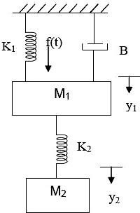

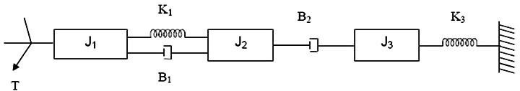
Write the Differential equations governing the mechanical rotational system shown in fig. and find the transfer function.

Find the transfer function C(S)/R(S) for the system shown in fig.
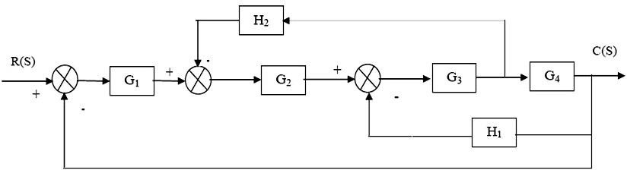

Obtain the overall gain C(S) / R(S) for the signal flow graph shown in fig..
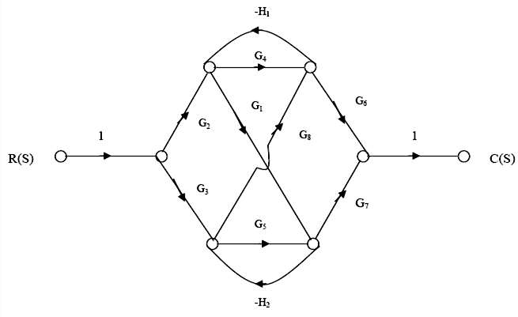

Block diagram reduction technique finds the transfer function for the system shown in fig.
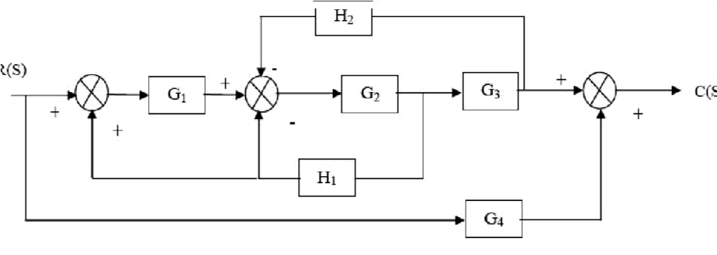

Find the overall gain C(S) / R(S) for the signal flow graph shown in fig.
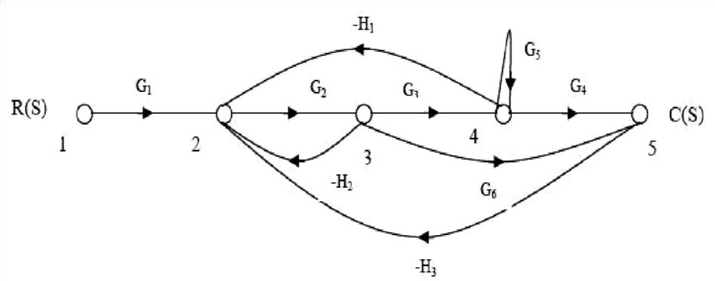

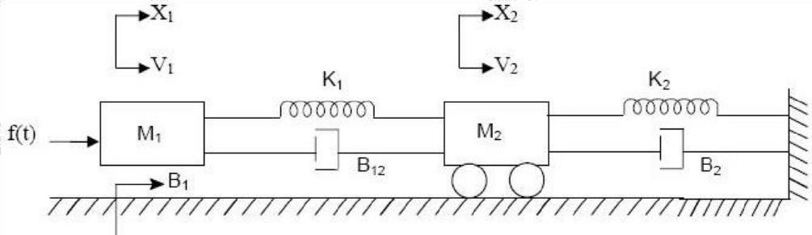
Write the differential equation governing the mechanical translational systems and find the transfer function. Draw the force voltage and force current electrical analogies.

Derive the transfer function for the armature and field controlled DC Motor.

Write the Differential equations governing the mechanical translational system shown in fig. and find the transfer function.

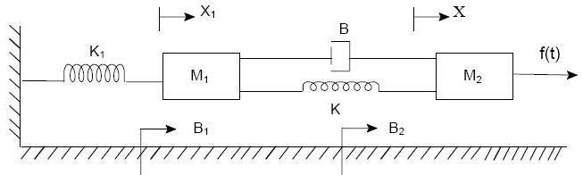

Derive the transfer function of the given signal flow graph.
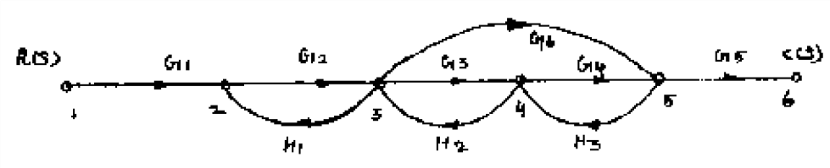

Draw a signal flow graph and find the closed loop transfer function for the block diagram shown in fig.
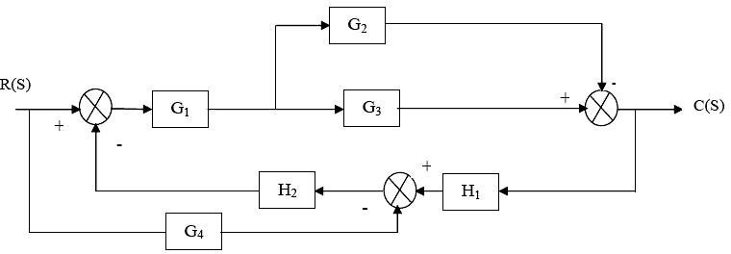

For the Block diagram shown in fig. Find C1 / R1 and C2 / R1
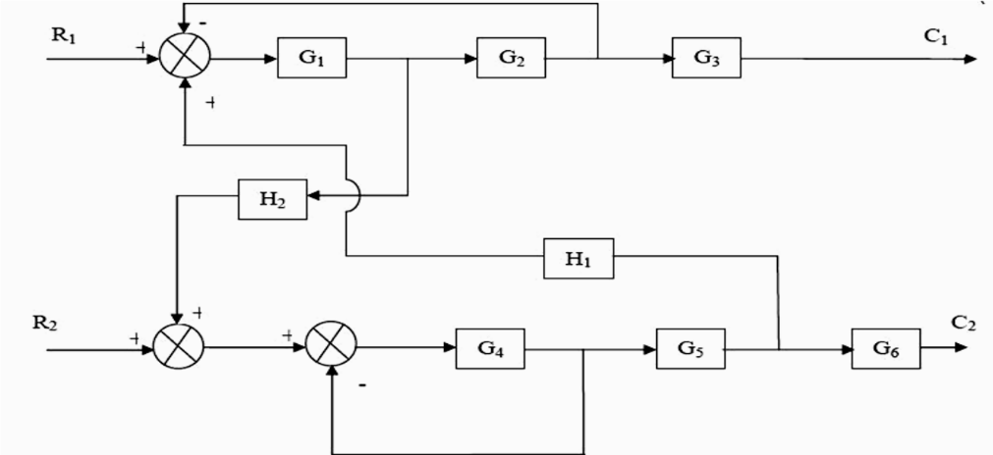

UNIT-II TIME RESPONSE ANALYSIS PART-A

- What are transient and steady state response of a control system?
The transient response is the response of the system when the system changes from one state to another. The steady state response is the response of the system when it approaches infinity.

- With reference to time response of a control system, define peak time.

The time taken for the response to reach the peak value for the first time is peak time. The time taken for response to raise from 0% to 100% for the very first time is rise time.

Distinguish between type and order of a system.
  - Type number is specified for loop transfer function but Order can be specified for any transfer function.
  - The Type number is given by number of poles of loop transfer function lying at origin of S- Plane but the order is given by the number of poles of transfer function.

What will be the nature of response of a second order system with different types of damping?
  - For Undamped System the response is Oscillatory.
  - For Underdamped System the response is damped Oscillatory.
  - For Critical Damped System the response is exponentially rising.
  - For Over damped System the response is exponentially rising but the rise time will be very large

List the advantages of generalized error coefficients.
  - Steady state is function of time.
  - Steady state can be determined from any type of input.
•

Give the steady state error to a various standard input for type - 2 systems.
  - Unit Step as Input : “0” Steady State Error.
  - Unit Ramp as Input : “0” Steady State Error.
  - Unit Parabolic as Input : Constant Steady State Error (1/Ka).

What is the effect of PID controller on the system performance?
The effect of PD controller is to increase the damping ratio of the system and so the peak overshoot is reduced.

What is first order and second order systems?
The order of a dynamic system is the order of the highest derivative of its governing differential equation. Equivalently, it is the highest power of “S” in the denominator of its transfer function.
If the power is 1, it is First order system.
If the Power is 2, it is Second order system.

Define delay time and rise time.
Delay Time is the time taken for response to reach 50% of the Final Value, the very first time. Rise Time is the time taken for response to raise from 0 to 100%, the very first time.

Describe peak overshoot and settling time.
Peak overshoot is defined as the ratio of maximum peak value measured from the maximum value to final value.
Settling time is defined as the time taken by the response to reach and stay within specified
error.

Why derivative controller is not used in control system?
The Derivative controller produces a control action based on rate of change of error signal and it does not produce corrective measures for any constant error. Hence derivative controller is not used in control systems.

What are type 0 and type 1 system?
The number of poles of the loop transfer function lying at the origin decides the type number of the system and denoted by “N”.
If N = 0, it is termed as Type – 0 System. If N = 1, it is termed as Type – 1 System.

- Give the units of K_{p}, K_{v} and K_{a}?
No Units. They are Constant.

The closed-loop transfer function of second order system is given below. Determine its damping ratio and natural frequency of oscillation. (AUC, May - June 2013)

C(S)/R(S) = 400/ S² +6S +400 ω2n /S2
+2Ϛωn s+ ω2n = 400/ S2 +6S +400
ω²n =400 2Ϛωn=6
ωn =20 Ϛ =6/2*20=0.15

PART-B
- Derive the expressions and draw the response of first order system for unit Step input. Ref : Control System Engineering by A NAGOORKANI, First Edition. Pg No 2.7

Consider a second order system Y(s)/R(s) = ω_{n}²/ s²+2ςω_{n}s+ω ² Find the response y(t) to a
n .
input of unit step function. (AUC, Nov-Dec 2012)
Ref : Control System Engineering by A NAGOORKANI, First Edition. Pg No 2.10

Explain A unity feedback control system has an open loop transfer function
G(s) = 1/(0.5s+1)(0.2s+1). Determine the steady state error for unit step, unit ramp, and unit acceleration inputs. Also determine the damping ratio and ω_{n} of the dominant roots. (AUC, Nov-Dec 2013)
Ref : Control System Engineering by A NAGOORKANI, First Edition. Pg No 2.43

Determine the steady state error of the system and generalized error coefficients when subjected to an input r(t) = 2+3t+t². (AUC, May - June 2014)
Ref : Control System Engineering by A NAGOORKANI, First Edition. Pg No 2.45

With a neat block diagram and Derivation explain how PI, PD and PID compensation will improve the time response of the system. (AUC, May-Jun, 2016)
Ref : Control System Engineering by A NAGOORKANI, First Edition. Pg No 2.52

- For a system G(s) H(s) = K₁(2s+1)/s(5s+2) (1+s)². Find the minimum value of K₁, to limit steady state error to 0.1 when input to system is 1+6t. (AUC, Nov-Dec 2012) Ref : Control System Engineering by A NAGOORKANI, First Edition. Pg No 2.48

The unity feedback control system is characterized by an open loop transfer function G(s) = K / [s(s+10)]. Determine the gain K, so that the system will have damping ratio of 0.5 for this value of K. Determine the peak overshoot and peak time for a unit step input. (AUC, May - June 2016)
Ref : Control System Engineering by A NAGOORKANI, First Edition. Pg No 2.24

Derive the time response analysis of a first order system for step and ramp input. (AUC, Nov- Dec 2015)
Ref : Control System Engineering by A NAGOORKANI, First Edition. Pg No 2.7

A certain unity negative feedback control system has the following forward path transfer function G(s)=k(s+2)/s(s+5)(4s+1). The input applied is r(t)=1+3t. Find the minimum value of k so that the steady state error is less than 1. (AUC, May - June 2012)
Ref : Control System Engineering by A NAGOORKANI, First Edition. Pg No 2.48

With a neat diagram, explain the function of PID Compensation in detail. (AUC, Nov-Dec 2015)
Ref : Control System Engineering by A NAGOORKANI, First Edition. Pg No 2.58

A unity feedback system has the forward transfer function 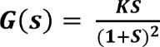 , For the input r(t)
= 1 + St, find the minimum value of K so that the steady state error is less than 0.1 (Use final value theorem)
Ref : Control System Engineering by A NAGOORKANI, First Edition. Pg No 2.48

Explain in detail about PI and PD Compensation.
Ref : Control System Engineering by A NAGOORKANI, First Edition. Pg No 2.55

UNIT-III FREQUENCY RESPONSE ANALYSIS PART-A

- List out the different frequency domain specifications?
Resonant Peak, Mr. Resonant Frequency, ωr.
Bandwidth, ωb.  Cut-off Rate  Gain Margin, Kg. Phase Margin, γ.

What is phase margin? (AUC, Nov-Dec 2013)
The Phase margin is the amount of phase lag at the gain cross over frequency required to bring system to the verge of instability.

Define –Gain Margin?
The Gain Margin, kg is defined as the reciprocal of the magnitude of the open loop transfer function at phase cross over frequency.

Define Corner frequency. (AUC, Nov-Dec 2012),(AUC, May - June 2014)
The frequency at which the two-asymptotic meet in a magnitude plot is called Corner frequency.

Define gain cross over frequency?
The Gain Cross Over Frequency is the frequency at which the magnitude of the open loop transfer function is unity.

State Nyquist stability Criterion for a closed loop system when the open loop system is stable. (AUC, Nov-Dec 2013)
If G(S)H(S) – Contour in the G(S)H(S) – Plane corresponding to Nyquist contour in S-plane encircles the point -1+j0 in the anticlockwise direction as many times as the number of right half S-plane poles of G(S)H(S). Then the closed loop is stable.

Draw the polar plot of G(s)=1/(1+sT). (AUC, May - June 2012)
Ref: Nagoorkani Pg.no: 4.89-Q.4.27 (Second edition)

Define Resonant frequency (μf)?
The maximum value of the magnitude of closed loop transfer function is called Resonant Peak. The frequency at which resonant peak occurs is called resonant frequency.

- What are the main advantages of Bode plot? The main advantages are:
  - Multiplication of magnitude can be into addition.
  - A simple method for sketching an approximate log curve is available.
  - It is based on asymptotic approximation. Such approximation is sufficient if rough information on the frequency response characteristic is needed.
  - The phase angle curves can be easily drawn if a template for the phase angle curve of 1+ j∆ is available.

Define Phase cross over frequency?

The Phase cross over frequency is the frequency at which the phase of the open loop transfer function is 180⁰.

The damping ratio and the undamped natural frequency of a second order system are 0.5 and 5 respectively. Calculate the resonant frequency. (AUC, May - June 2014)

- What is Nichols chart? (AUC, Nov-Dec 2012)
The chart consisting of M & N loci in the log magnitude versus phase diagram is called Nichols chart. A Nichols chart displays the magnitude (in dB) plotted against the phase (in degrees) of the system response.

What are Constant M and N Circles? (AUC, Nov-Dec 2015)
The magnitude of closed loop transfer function with unit feedback can be shown for every value of M. These circles are called M circles.
The Phase of closed loop transfer function with unit feedback can be shown for every value of M. These circles are called M circles.

- Draw the polar plot of an integral term transfer function. (AUC, May - June 2013) Ref: Nagoor kani Pg.no: 4.40 (Second edition)

PART-B

- Sketch the Bode plot for the following transfer function and determine the Phase margin and Gain margin. 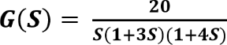
Ref : Control System Engineering by A NAGOORKANI, First Edition First Edition. Pg No 3.32

Sketch the polar plot for the following transfer function .and find Gain cross over frequency, Phase cross over frequency, Gain margin and Phase margin. G(S) = 400/S(S+2)(S+10) Ref
: Control System Engineering by A NAGOORKANI, First Edition. Pg No 3.51

The open loop transfer function of unity feedback system is given by (𝑺) = 𝟏/[𝒔(𝟏 + 𝒔)𝟐]. Sketch the polar plot and determines the gain margin and phase margin. (AUC, Nov-Dec 2016)
Ref : Control System Engineering by A NAGOORKANI, First Edition. Pg No 3.51

Write down the procedure for designing Lag Compensator using Bode plot. (AUC, Nov-Dec 2016)
Ref : Control System Engineering by A NAGOORKANI, First Edition. Pg No 5.8

Sketch the Nyquist plot for a system with the open loop transfer function G(S) H(S) =K (1+0.5S) (1+S) / (1+10S) (S-1). Determine the range of values of K for which the system is stable.
Ref : Control System Engineering by A NAGOORKANI, First Edition. Pg No 4.46

Design the lead compensator for the system G(s) = 1/S(S+2) with damping coefficient equal to 0.45, velocity error constant>20 and small setting time.
Ref : Control System Engineering by A NAGOORKANI, First Edition. Pg No 5.32

- For the following transfer function G(s) = k(s+3)/s(s+1))s+2). Sketch the Bode magnitude plot by showing slope contributions from each pole and zero. (AUC, May - June 2012) Ref : Control System Engineering by A NAGOORKANI, First Edition. Pg No 3.35

Given G(s) = Ke-^{0.2s}/ s(s+2)(s+8), find K for the following two cases.
  - Gain margin equal to 6db

Phase margin equal to 45ᶿ. (AUC, Nov-Dec 2012)
Ref : Control System Engineering by A NAGOORKANI, First Edition. Pg No 3.27

The open loop transfer function of unity feedback system is given by, 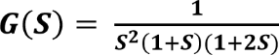, Sketch the polar plot and determine the gain margin and phase margin.
Ref : Control System Engineering by A NAGOORKANI, First Edition. Pg No 3.45

The open loop transfer function of unity feedback system is given by (𝑺) = 𝟏/[𝒔(𝟏 + 𝒔)𝟐]. Sketch the polar plot and determines the gain margin and phase margin. (AUC, Nov-Dec 2016)
Ref : Control System Engineering by A NAGOORKANI, First Edition. Pg No 3.51

- For a certain system, G(S) = K / S (S+1) ( S+2). Design a suitable lag - lead compensator to give, velocity error constant = 10 sec⁻¹ phase margin = 50˚, gain margin ≥ 10 dB. Ref : Control System Engineering by A NAGOORKANI, First Edition. Pg No 5.55

Explain in detail the design procedure of lead compensator using Bode plot. (AUC May – June 2013)
Ref : Control System Engineering by A NAGOORKANI, First Edition. Pg No 5.30

UNIT-IV CONCEPT OF STABILITY ANALYSIS

PART-A

- Define stability.
A linear relaxed system is said to have BIBIO stability if every bounded input results in a bounded output.

What is the necessary condition and sufficient condition for stability in routh stability criterion? (AUC May – June 2013)
Routh criterion states that the necessary and sufficient condition for stability is that all of the elements in the first column of the routh array is positive. If this condition is not met, the system is unstable and the number of sign changes in the elements of the first column of routh array corresponds to the number of roots of characteristic equation in the right half of the S-plane.

What is meant by Relative stability? (AUC, May - June 2014)
Relative stability is the degree of closeness of the system, it is an indication of strength or degree of stability.

What is a dominant pole?
The dominant pole is a complex conjugate pair which decides the transient response of the system.

What is root locus? Explain with suitable example. (AUC, May - June 2012)
The path taken by the roots of the open loop transfer function when the loop gain is varied from 0 to 1 are called root loci.

State Nyquist stability criterion. (AUC, May - June 2012)
If the Nyquist plot of the open loop transfer function G(s) corresponding to the Nyquist control in the S-plane encircles the critical point –1+j0 in the counter clockwise direction as many times as the number of right half S-plane poles of G(s), the closed loop system is stable.

Write the necessary and sufficient condition for stability in routh stability criterion. (AUC, May - June 2013
The necessary condition for stability is that all the coefficients of the characteristic polynomial be positive. The necessary and sufficient condition for stability is that all of the elements in the first column of the routh array should be positive.

Define Routh Hurwitz stability criterion.
Routh criterion states that the necessary and sufficient condition for stability is that all of the elements in the first column of the routh array is positive. If this condition is not met, the system is unstable and the number of sign changes in the elements of the first column of routh array corresponds to the number of roots of characteristic equation in the right half of the S-plane.

Write a note on angle and magnitude condition of root locus.
The angle criterion states that S =Sa will be a point on root locus if for that value the phase of G(S)H(S) is equal to odd multiple of 180⁰.
The Magnitude Criterion states that S = Sa will be a point on root locus if for that value of S Magnitude of G(S)H(S) is equal to 1.

Write the characteristics equation for closed loop system.
C(s)/R(s)= G(s)/1+G(s).H(s)
The characteristics equation is,

1+G(s).H(s)=0,
G(s).H(s) = -1 this equation can be converted to two Evans conditions

G(s).H(s) = +1

- What are root loci?

The path taken by a root of characteristic equation when open loop gain K is varied from 0 to is called root loci.

Describe the terms: (i) Asymptotes (ii).Centroid (iii). Breakaway point
Asymptotes are straight lines which are parallel to root locus going to infinity and meet the root locus at infinity.
  - The meeting point of asymptotes with real axis is called centroid.
  - The Point at which the root locus breaks from the real axis to enter into the complex plane is called as Break away point.

Explain the method of calculating breakaway point.
At break away point the root locus breaks from the real axis to enter into the complex plane. At break in point the root locus enters the real axis from the complex plane. To find the break away or break in points, form a equation for K from the characteristic equation and differentiate the equation of K with respect to s. Then find the roots of the equation dK/dS = 0. The roots of dK/dS
= 0 are break away or break in points provided for this value of root the gain K should be positive and real.

- State any two limitation of Routh stability criterion. (AUC, Nov – Dec 2012)  It is valid only if the Characteristic equation is algebraic.
  - If any co-efficient of the Characteristic equation is complex or contains power of ‘e’ this criterion cannot be applied.
  - It gives information about how many roots are lying in the RHS of S-plane; values of the roots are not available. Also it cannot distinguish between real & complex roots.

PART-B

- Construct Routh array and determine the stability of the system whose characteristic equation is, S⁶ + 2S⁵ + 8S⁴ + 12S³ + 20S² + 16S+16 = 0. (AUC, May - June 2012) Ref : Control System Engineering by A NAGOORKANI, First Edition. Pg No 4.13
- Find the range of K for stability of s⁴ +2s³ + 2s² + (3+K)s + K = 0 ,for k>0 Ref : Control System Engineering by A NAGOORKANI, First Edition. Pg No 4.23

Sketch the root locus of the system whose open loop transfer function is given below. Find the value of K so that the damping ratio of the closed loop system is 0.5, G(S) = K / S (S+2)
  - (S+4) (AUC, May - June 2012)
  - Ref : Control System Engineering by A NAGOORKANI, First Edition. Pg No 4.72

A unity feedback control system has an open loop transfer function given below, Sketch the root locus. G(S) = K (S+9) / S (S2+4S+11)
  - Ref : Control System Engineering by A NAGOORKANI, First Edition. Pg No 4.75

Construct R-H Criterion and determine the stability of a system representing the characteristic equation S⁵+S⁴+2S³+2S²+3S¹+5 = 0. Comment on location of roots of the characteristic equation.
  - Ref : Control System Engineering by A NAGOORKANI, First Edition. Pg No 4.14

Write detailed notes on relative stability with its roots of s-plane.
  - Ref : Control System Engineering by A NAGOORKANI, First Edition. Pg No 4.54

Determine the range of K for stability of unity feedback system whose open loop transfer function G(s) = K/ s(s+1)(s+2) using Routh stability criterion. (AUC, Nov-Dec 2012)
  - Ref : Control System Engineering by A NAGOORKANI, First Edition. Pg No 4.22

- Draw the approximate root locus diagram for a closed loop system whose loop transfer function is given by G(s) H(s) =K/S(s+15)(s+10). (AUC, Nov-Dec 2012) Ref : Control System Engineering by A NAGOORKANI, First Edition. Pg No 4.69

Draw the Nyquist plot for the system whose open loop transfer function is,
a. G(S) = K / S (S+2) (S+10). (AUC, May - June 2012)
b. Ref : Control System Engineering by A NAGOORKANI, First Edition. Pg No 4.35

Sketch the root locus of the system whose open loop transfer function is give below. Find the value of K so that the damping ratio of the closed loop system is 0.5. G(S) = K / S (S+2) (S+4) (AUC, May - June 2012)
  - Ref : Control System Engineering by A NAGOORKANI, First Edition. Pg No 4.72

Sketch the Nyquist Plot for a system with the open loop transfer function given below.
  - Determine the range of k for which closed loop system is stable.

b. G(S) H(S) = K (1+0.5S) (1+S) / (1+10S) (S-1)
c. Ref : Control System Engineering by A NAGOORKANI, First Edition. Pg No 4.46

Determine the stability of closed loop system by Nyquist stability criterion, whose open loop transfer function is given by, G(S) H(S) = (s+2)/(s+1)(s-1).
  - Ref : Control System Engineering by A NAGOORKANI, First Edition. Pg No 4.52

UNIT-V CONTROL SYSTEM ANALYSIS USING STATE VARIABLE METHODS

PART-A

- Draw Sampler and Hold Circuit. (AUC, Nov-Dec 2016)
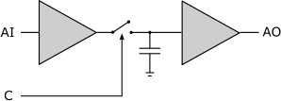

Define Observability of a system. (AUC, Nov-Dec 2015)
A System is said to be completely observable if every state X(t) can be completely identified by measurements of the output Y(t) over a finite time interval.

What is the necessity of compensation in feedback control system? (AUC, May-June 2014)
The necessity of compensation is its consideration of saturation and transient performance in addition to the usual steady-state behavior.

- Write the transfer function of lag-lead compensator.? (AUC, May-June 2014) G(S) = ((s+1)/T1)(s+1/T2)) / ((s+1/(βT1)(s+β/T2))

Define state transition matrix using classical method.
The Matrix in which we can list the transition probabilities is called as State Transition Matrix and is usually shown by P.

Give the concept of controllability. (AUC, Nov - Dec 2013)
A system is said to be completely state controllable if ti is possible to transfer the system state from any initial state , to any other desired state in specified finite time by a control vector.

Define state variables and state vectors. ( AUC May – June 2013)
  - A set of variable which describes the state of the system at any time instant are called state
variables.
  - The state vector is a (n*1) column matrix whose elements are state variables of the system.

What is state trajectory?
State Trajectory is a trajectory is the set of points in state space that are the future states resulting from a given initial state.

Define state and state variables of a model system. (AUC, Nov - Dec 2012, May-Jun 2016)
A state variable is one of the set of variables that are used to describe the mathematical "state" of a dynamical system. Intuitively, the state of a system describes enough about the system to determine its future behaviour in the absence of any external forces affecting the system.

What is homogeneous and non-homogeneous state equation?
An equation in differential form M(x,y) dx + N(x,y) dy = 0 is said to be. homogeneous, if when written in derivative form.

Describe feedback compensation.
The feedback compensation is a design procedure in which a compensator is placed an internal feedback path around one or more components of the forward path so as to meet the desired specifications.

What is Zero order hold circuit? (AUC, May - June 2016)
The zero-order hold (ZOH) is a mathematical model of the practical signal reconstruction done by a conventional digital-to-analog converter (DAC). That is, it describes the effect of converting a discrete-time signal to a continuous-time signal by holding each sample value for one sample interval.

State sampling Theorem. (AUC, Nov-Dec 2016)
A band limited signal can be reconstructed exactly if it is sampled at a rate at least twice the maximum frequency component in it.

PART-B
- What are the Sampled data control system? With an aid of a block diagram show basic elements of a sampled data control system and give functioning of these elements. (AUC, NOV/DEC:2017)
Ref: Nagrath and Gopal (Fifth Edition), Pg No :515.

Test the Controllability & Observability of the system by any one method whose state space representation is given as,
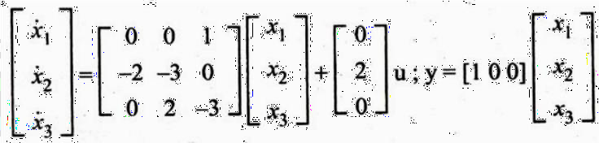
Ref: Control System Engineering by A NAGOORKANI, First Edition. Pg No 6.62

Consider a unity feedback system with open loop transfer function. G(S) = 75/(s+1)(s+3)(s+8). Design A PID controller to satisfy the following specifications. (a) the steady state error for unit ramp input should be less than 0.08. (b) Damping ratio = 0.8. (c) Natural frequency of oscillation = 2.5 rad/sec.
Ref: Control System Engineering by A NAGOORKANI, First Edition. Pg No 6.86

Consider the system defined by, X= Ax-BU; Y=Cx; Where, Check the Controllability and Observability of the system.
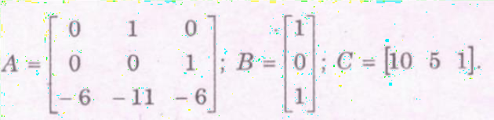
Ref: Control System Engineering by A NAGOORKANI, First Edition. Pg No 6.62

Construct a state model for a system characterized by the differential equation (d³y/dt³)+ 6(d²y/dt²) + 11 (dy/dt) +6y + u =0
Ref : Control System Engineering by A NAGOORKANI, First Edition. Pg No 6.26

With neat block diagram explain the sampled data control system and state its advantages
Ref : Control System Engineering by A NAGOORKANI, First Edition. Pg No 7.1

Explain the functional modules of closed loop sampled data system and compare its performance with open loop sampled data system. (AUC, Apr-May 2015)
Ref : Control system Engineering by I.J. Nagrath and M.Gopal. fifth Edition Pg. No.515

Consider a system with state-space model given below,
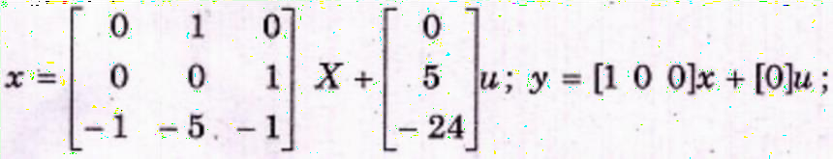
Verify that the system is observable and controllable. (AUC, Apr-May 2015)
Ref : Control System Engineering by A NAGOORKANI, First Edition. Pg No 6.62

Describe the procedure for the design of lag compensator using Bode Plot. (AUC, May – June 2014)
Ref : Control System Engineering by A NAGOORKANI, First Edition. Pg No 5.8

Explain the electric network realization of lead compensator and also its frequency. (AUC, May – June 2014)
Ref : Control System Engineering by A NAGOORKANI, First Edition. Pg No 5.27

Write detailed notes on Sampler and Hold circuit.
Ref : Control System Engineering by A NAGOORKANI, First Edition. Pg No 7.5

Obtain the state model of the system described by the following transfer function, y(s)/u(s)
=5/s³+6s+7. (AUC, May - June 2014)
Ref : Control System Engineering by A NAGOORKANI, First Edition. Pg No 6.2

